Manual

Active
Collaboration Soundbar

SP-ASCM
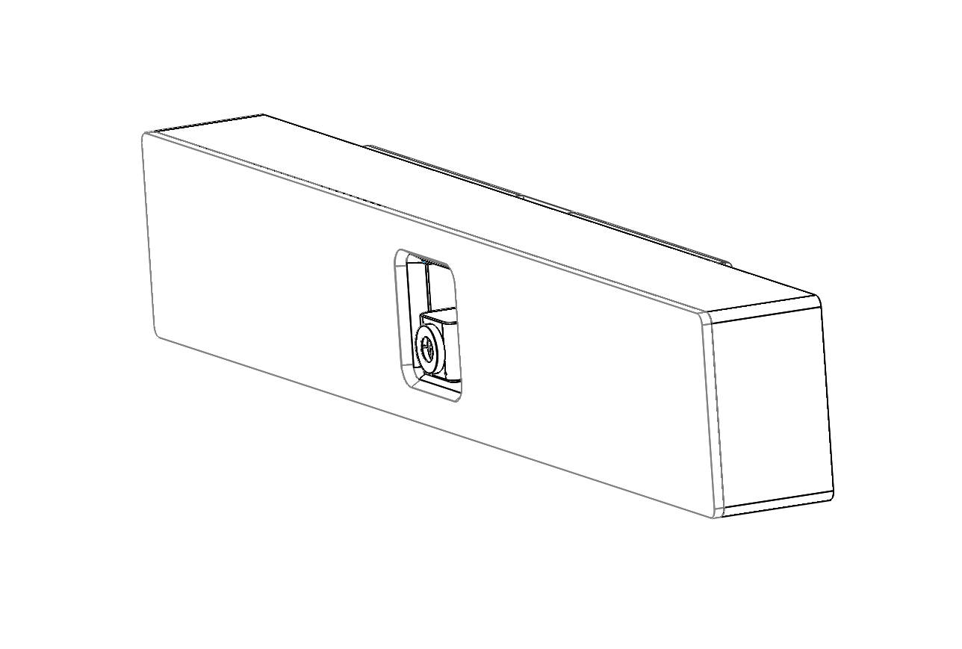

Parallelperspektive möglich?

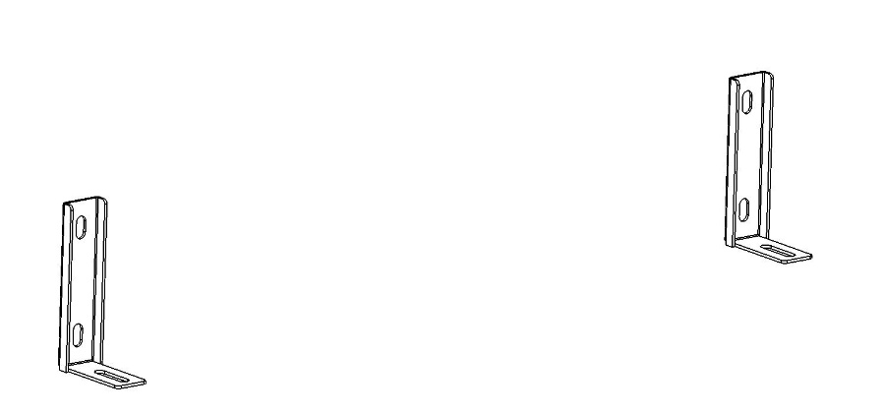
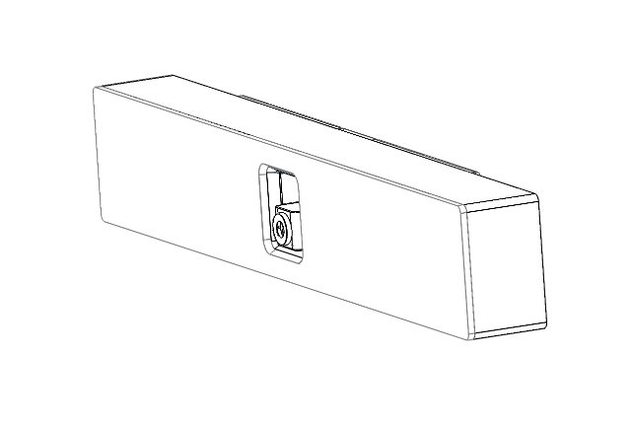
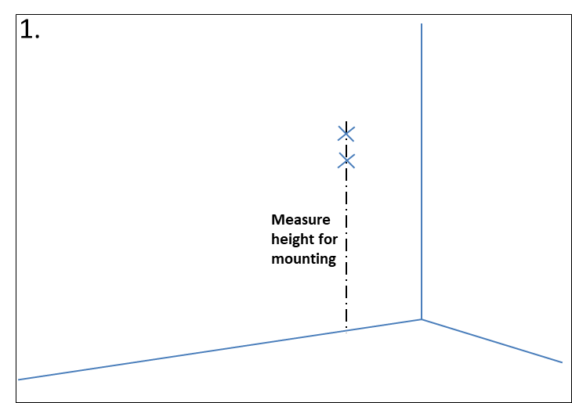
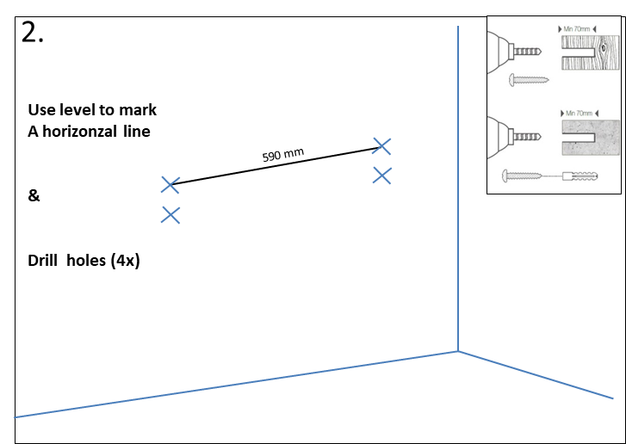
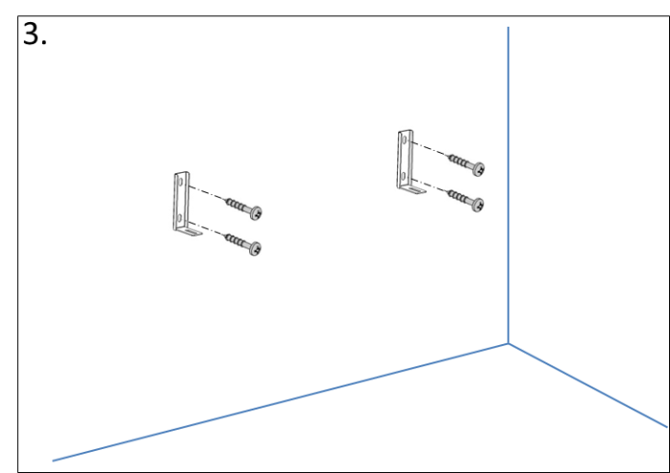
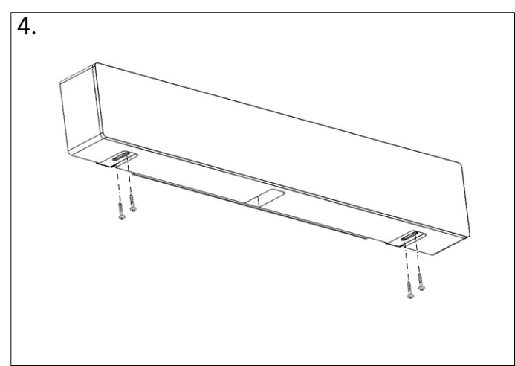
Collaborative Soundbar including 2x USB-Cable + power supply
Wallmount
4x M3 Screws + washers
2) Assembly to the wall
1) Delivery
3) Connection

Camera USB (3.0) USB port 2.0 of the external device
Microphone USB (2.0) USB port 2.0 of the external device

4) Devices

Playback device “2 – Phnx MT103_16k”
Recording device “2 – Phnx MT103_16k”

